ABINAV S T  
230701007

EXP NO:7 IPC USING SHARED MEMORY

PROGRAM

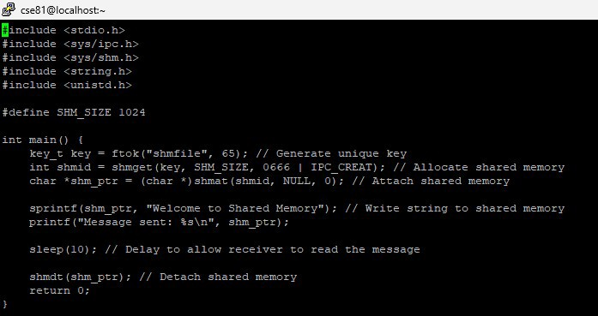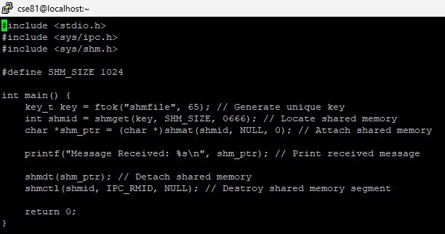

OUTPUT

